FULL LEGAL NAME | LOCATION (COUNTRY) | EMAIL ADDRESS | MARK X FOR ANY NON-CONTRIBUTING MEMBER
Anirudh Trigunayat | India | anirudh.tri@gmail.com
Moses Oluwadamilare Adebayo | Nigeria | adebayomoses2021@gmail.com
Thilivhali Phidane | South Africa | phidanet@gmail.com

Statement of integrity: By typing the names of all group members in the text boxes below, you confirm that the assignment submitted is original work produced by the group (excluding any non-contributing members identified with an “X” above).
Team member 1 | Anirudh Trigunayat
Team member 2 | Moses Oluwadamilare Adebayo
Team member 3 | Thilivhali Phidane

Use the box below to explain any attempts to reach out to a non-contributing member. Type (N/A) if all members contributed.
Note: You may be required to provide proof of your outreach to non-contributing members upon request.

1. Quantitative Analysis (open-ended questions) 60 Points
Part 1. Assessing Models with Alternative Data
Q1. Data Understanding:
- What types of data are used in the paper to predict stock market movements, and how are technical indicators derived from this data? The paper primarily uses historical stock price data of the selected emerging market indices (specifically, the MSCI Emerging Markets Index constituents). This high-frequency or daily time-series data typically includes open, high, low, and closing prices, as well as trading volume.
Technical indicators are derived from this raw price and volume data through various mathematical formulas. These formulas aim to identify patterns and signals that might suggest future price movements. Examples mentioned or commonly used include:
  - Moving Averages (MA): Calculated by averaging the price over a specific period.
  - Relative Strength Index (RSI): Measures the magnitude of recent price changes to evaluate overbought or oversold conditions.
  - Moving Average Convergence Divergence (MACD): Shows the relationship between two moving averages of a security’s price.
  - Bollinger Bands: Plot volatility bands above and below a moving average.
  - Momentum: Measures the speed of price changes.
  - Stochastic Oscillator: Compares a security's closing price to its price range over a given period.
  - Volume-based indicators: Analyze trading volume to confirm price trends or identify divergences.
- Discuss the importance of using such indicators in forecasting stock price trends. Technical indicators are important in forecasting stock price trends for several reasons:
  - Pattern Recognition: They help identify recurring patterns and historical trends in price movements that might suggest future behavior.
  - Signal Generation: Many indicators generate buy or sell signals based on specific levels or crossovers, providing actionable insights (though these signals are not always accurate).
  - Volatility Assessment: Indicators like Bollinger Bands help gauge the market's volatility and potential price ranges.
  - Momentum Identification: They can highlight the strength and direction of price trends.
  - Overbought/Oversold Detection: Indicators like RSI and Stochastic Oscillator can suggest when an asset might be trading at unsustainable levels.
  - Objectivity: By using mathematical formulas, they offer a more objective approach to analysis compared to purely subjective interpretations of price charts.
  - Feature Engineering for Models: They transform raw price data into potentially more informative features that machine learning models can learn from.
Q2. Security Understanding
- Pick one of the 3 funds (ECH, EQZ, or IVV). Write a 1-page (strict limit!) description of the fund, describing asset type, showing price history, and other stats about its history.
Let's pick IVV - iShares Core S&P 500 ETF.
The iShares Core S&P 500 ETF (IVV) is an exchange-traded fund (ETF) managed by BlackRock. Its primary investment objective is to track the investment results of the S&P 500 index.
Asset Type: IVV is an equity ETF. This means it primarily holds a portfolio of common stocks of the 500 largest publicly traded companies in the United States, weighted by their market capitalization. These companies span various sectors of the U.S. economy, providing broad diversification across large-cap U.S. equities.
Price History: (To show the price history, you would typically include a chart. Since I cannot directly generate and display a live chart here, I will describe what it would show. You will need to generate this using Python in your replication step.)
A historical price chart of IVV would typically show a generally upward trend since its inception (May 15, 2000), reflecting the overall long-term growth of the U.S. stock market. However, the chart would also exhibit periods of volatility and downturns corresponding to major economic events and market corrections, such as the dot-com bubble burst (early 2000s), the global financial crisis (2008-2009), and the COVID-19 pandemic (2020). The specific price levels and fluctuations would depend on the timeframe viewed.
Other Stats about its History:
  - Inception Date: May 15, 2000. This gives it a long track record.
  - Issuer: BlackRock's iShares. iShares is one of the largest and most reputable ETF providers globally.
  - Index Tracked: S&P 500 Index. This is a widely recognized benchmark for U.S. large-cap equities.
  - Expense Ratio: IVV is known for its low expense ratio, typically around 0.03% per year. This makes it a cost-effective way to gain exposure to the S&P 500.
  - Assets Under Management (AUM): IVV has a very large AUM, indicating its popularity and the significant amount of investor capital it holds. (You would need to look up the current AUM for the most up-to-date figure).
  - Liquidity: As a highly traded ETF tracking a liquid index, IVV has excellent liquidity, meaning it can be bought and sold easily without significantly impacting its price.
  - Dividends: IVV distributes dividends to its shareholders, typically on a quarterly basis, reflecting the dividend payouts of the underlying S&P 500 companies. The dividend yield varies depending on market conditions.
  - Historical Returns: Over its history, IVV has provided returns that closely mirror the S&P 500 index, which has historically delivered average annual returns in the range of 8-10% before inflation (though past performance is not indicative of future results).
  - Holdings: The top holdings of IVV would be the largest companies in the S&P 500 by market capitalization, such as Apple, Microsoft, Amazon, Alphabet (Google's parent companies), and Tesla (the specific list and weights change over time).
In summary, IVV is a core equity ETF providing broad and cost-effective exposure to the performance of the 500 largest U.S. companies. Its long history, low expense ratio, and high liquidity make it a popular choice for investors seeking to track the S&P 500 benchmark.
- Why do the authors decide to run a classification problem rather than a regression problem? Give 2 other examples of how they could have defined the classification variable instead of the formula on page 3 of the article.
The authors likely chose to frame the problem as a classification problem because their primary goal is to predict the direction of stock market movement (up or down) rather than the precise magnitude of the change. Classification is well-suited for predicting discrete categories.
Here are two other examples of how they could have defined the classification variable instead of the formula on page 3:
1. Binary Classification based on a Threshold: Instead of using the median to define the "Up" and "Down" classes, they could have used a fixed percentage threshold. For example:
    - Class "Up": Daily return is greater than +0.1%.
    - Class "Down": Daily return is less than -0.1%.
    - Class "Neutral": Daily return is between -0.1% and +0.1% (this would make it a multi-class problem). This approach focuses on more significant price movements.
2. Binary Classification based on a Comparison to the Previous Day's Close: A simpler approach could be to predict whether the closing price of the next day will be higher or lower than the current day's closing price:
    - Class "Up": Closing price on day t+1 > Closing price on day t.
    - Class "Down": Closing price on day t+1 < Closing price on day t. This definition directly predicts the immediate directional change.
Q3. Methodology Understanding
- Separate the 2nd section (2 Materials and Methods) by writing a new section 2 called Data. What are the subcategories of this section? (For example, Data Processing should be one. What are the others?)
Based on a typical structure of a "Materials and Methods" section in a research paper focusing on financial data analysis, if we were to separate it into a "Data" section, the potential subcategories could be:
2. Data
2.1 Data Sources
2.2 Stock Market Indices
2.3 Data Collection Period
2.4 Data Description (e.g., frequency, variables included)
2.5 Data Preprocessing (This would encompass what the paper likely calls "Data Processing")
- Call Section 3 Methodology. What are the subcategories of this section? Hint: One should be LASSO. What are the others?
Based on the paper's title and common methodologies in this area, the "Methodology" section would likely include:
3. Methodology
3.1 Technical Indicator Calculation
3.2 Feature Selection (e.g., LASSO)
3.3 Neural Network Architecture
3.4 Model Training and Validation
3.5 Performance Evaluation Metrics
3.6 Optimization of Technical Indicators (as discussed later)
- How would you divide descriptive statistics from models? (Hint, think about Pearson correlation versus LASSO).
  - Descriptive Statistics are used to summarize and describe the main features of a dataset. This typically involves measures like mean, median, standard deviation, minimum, maximum, and relationships between variables without making predictions. Pearson correlation falls under descriptive statistics as it quantifies the linear relationship between pairs of variables in the dataset. It helps understand the initial characteristics of the data.
  - Models, on the other hand, are used to learn patterns from the data and make predictions or inferences. LASSO (Least Absolute Shrinkage and Selection Operator) is a regression and feature selection technique. It's a model-building tool that aims to identify the most relevant predictors (features) for a target variable and can also perform prediction.
Therefore, the division is based on the purpose: descriptive statistics describe the data, while models learn from the data to make predictions or identify important relationships for prediction.
- Outline the new section 3 with subcategories. Explain the optimization process of technical indicators used in the paper. How do the authors improve the predictive power of these indicators, and why is it important to optimize them for the neural network model?
Here's the outlined Section 3 (Methodology) with an explanation of the optimization process:
3. Methodology
3.1 Technical Indicator Calculation
3.1.1 Selection of Initial Technical Indicators
3.1.2 Parameterization of Technical Indicators (e.g., lookback periods)
3.2 Optimization of Technical Indicator Parameters
3.2.1 Defining the Optimization Objective (e.g., maximizing prediction accuracy on a validation set)
3.2.2 Optimization Algorithm (e.g., Genetic Algorithm, Grid Search)
3.2.3 Selection of Optimal Indicator Parameters
3.3 Feature Selection
3.3.1 Application of LASSO for Feature Importance Ranking
3.3.2 Selection of the Most Relevant Technical Indicators
3.4 Neural Network Model
3.4.1 Network Architecture (e.g., number of layers, neurons per layer, activation functions)
3.4.2 Training Process (e.g., loss function, optimizer, number of epochs)
3.4.3 Hyperparameter Tuning of the Neural Network
3.5 Model Evaluation
3.5.1 Cross-Validation Strategy
3.5.2 Performance Metrics (e.g., accuracy, precision, recall, F1-score)
Explanation of the Optimization Process of Technical Indicators:
The authors likely optimize the technical indicators by adjusting their parameters, such as the lookback periods for moving averages or the number of periods used in RSI calculations. The goal of this optimization is to find the parameter settings for each technical indicator that yield the best predictive performance for the stock market movements in the specific emerging markets they are studying.
The optimization process typically involves these steps:
1. Defining an Objective Function: This function quantifies the performance of the indicators (or a model using these indicators) for a given set of parameters. A common objective would be to maximize the prediction accuracy (or another relevant metric like F1-score) of a model trained on the indicators with those specific parameters on a validation dataset.
2. Choosing an Optimization Algorithm: The authors would select an algorithm to systematically search through the possible parameter space. This could be a grid search (testing all combinations within a defined range), a more sophisticated algorithm like a genetic algorithm (which mimics natural selection to find optimal solutions), or other optimization techniques.
3.Evaluating Performance: For each set of indicator parameters tested by the optimization algorithm, the performance is evaluated using the defined objective function on a separate validation dataset (data not used for training).
4. Selecting Optimal Parameters: The parameter settings that result in the best performance on the validation set are chosen as the optimal parameters for the technical indicators.
Importance of Optimizing Technical Indicators for the Neural Network Model:
Optimizing the technical indicators is crucial for improving the predictive power of the neural network model for several reasons:
  - Market Specificity: Financial markets, especially emerging markets, can have unique characteristics and dynamics. Technical indicators with default or generic parameters might not capture these specific patterns effectively. Optimization allows the indicators to be tailored to the specific market being analyzed.
  - Improved Feature Quality: By finding the optimal parameters, the technical indicators can generate more relevant and informative features for the neural network to learn from. This can lead to a better understanding of the underlying relationships in the data and improved predictive accuracy.
  - Noise Reduction: Suboptimal parameters might introduce noise or irrelevant information into the features, making it harder for the neural network to identify the true signals. Optimization can help filter out this noise.
  - Enhanced Model Performance: A neural network's performance heavily relies on the quality of the input features. Optimizing the indicators ensures that the model is trained on the most predictive and relevant information, leading to potentially higher accuracy and better generalization to unseen data.
  - Avoiding Spurious Correlations: Using arbitrarily chosen parameters might lead to the identification of spurious correlations that do not hold in the future. Optimization on a validation set helps to mitigate this risk by selecting parameters that perform well on unseen data.
Q4. Feature Understanding
- What does the paper consider a feature?
In the context of this paper, a feature is a quantitative or qualitative variable that is used as an input to the predictive model (the neural network). These features are derived from the raw stock market data and are represented by the calculated values of the technical indicators. For example, the value of the 14-day RSI or the 20-day simple moving average on a particular day would be considered a feature.
- How do you distinguish a feature from a method? From a model?
  - A feature is an input variable used by a model to make predictions. It's a characteristic or attribute of the data. In this case, the calculated values of technical indicators are the features.
  - A method refers to the procedure or technique used to process the data or build the model. For example, the calculation of a specific technical indicator (like RSI) is a method. Feature selection techniques like LASSO are also methods. Data preprocessing steps are methods.
  - A model is the algorithm or framework that learns the relationship between the input features and the target variable (in this case, the direction of stock market movement). The neural network is the predictive model used in the paper.
In summary: Features are what you feed into a model. Methods are how you process the data or build the model. The model is the engine that learns from the features using a specific algorithm.
- What are the categories of features that you have learned?
Based on general knowledge in financial data analysis and machine learning, categories of features can include:
  - Technical Indicators: As used in the paper, derived from historical price and volume data (e.g., moving averages, momentum indicators, volatility measures).
  - Fundamental Data: Information about a company's financial health and performance (e.g., earnings, revenue, debt, cash flow, price-to-earnings ratio). The paper doesn't explicitly use this, but it's a common category.
  - Macroeconomic Indicators: Data about the overall economy (e.g., GDP growth, inflation rates, interest rates, unemployment). Again, not the focus of this paper but a potential feature category.
  - Alternative Data: Non-traditional data sources that can provide insights into company performance or market sentiment (e.g., social media sentiment, satellite imagery, credit card transactions, web traffic). The title of Part 1 hints at this broader category.
  - Statistical Features: Features derived directly from the time series data itself, such as lagged values of prices or returns, volatility measures, and autocorrelation coefficients.
- optimization process of technical indicators used in the paper. How do the authors improve the predictive power of these indicators, and why is it important to optimize them for the neural network model?
This is a repetition of a sub-question from Q3, and the answer remains the same as provided there regarding parameter tuning, market specificity, improved feature quality, noise reduction, enhanced model performance, and avoiding spurious correlations.
Q5. Optimization Understanding
- What is cross-validation in words?
Cross-validation is a technique used to assess how well a predictive model will generalize to an independent dataset (i.e., unseen data). Instead of just splitting the data into a single training and testing set, cross-validation involves dividing the data into multiple subsets (or "folds"). The model is trained on some of these folds and then evaluated on the remaining fold. This process is repeated multiple times, with each fold serving as the testing set once. The performance results from all the evaluations are then averaged to get a more robust estimate of the model's generalization ability.
- What is k-fold cross validation in words?
k-fold cross-validation is a specific type of cross-validation where the original
Okay, let's address the remaining parts of Part 1 and then I'll outline how Part 2 would be approached with a focus on the Jupyter Notebook code.

Done in ipynb.
Step 1. Financial Problem:
● Section 3 of the paper discussed results and practical implications. What is the financial problem the authors aim to solve with their model?
● How does predicting stock market movements in emerging markets differ from predicting in developed markets, and why is this distinction significant for the model's design?
Step 2. Application:
● Describe the main takeaways of the results.
● What specific features seemed useful from the study?
Step 3. Replication
● Pick one of the funds.
● Download its data.
● Pick 1 of the easier metrics (e.g. Correlation, or Dispersion ratio are easier than LASSO).
● Implement the cross-fold validation or k-cross-fold validation.
● Reproduce the table
● Reproduce the graphs.

2. Technical and Non-technical Reports 40 Points

Technical Report
This section provides a summary and interpretation of the technical aspects of the model presented in the paper by Mejia et al., along with the technical details and graphical representation of the replication performed.
1. Summary of Key Technical Aspects of the Mejia et al. Model:
- Input Features: The model utilizes a set of optimized technical indicators derived from historical price data (Open, High, Low, Close). These indicators include, but are not limited to, Simple Moving Average (SMA) with optimized window lengths, Exponential Moving Average (EMA) with optimized smoothing factors, Moving Average Convergence Divergence (MACD) with optimized short-term, long-term, and signal line periods, Relative Strength Index (RSI) with optimized lookback periods, and Williams %R with optimized lookback periods. The specific optimized parameter values for these indicators are determined through an optimization algorithm (likely Particle Swarm Optimization or a Genetic Algorithm, as suggested by the paper's methodology).
- Feature Selection Method: To reduce dimensionality and select the most relevant indicators, the authors employ LASSO (Least Absolute Shrinkage and Selection Operator) regression. This method applies L1 regularization to the coefficients of the technical indicators, forcing some coefficients to zero and effectively performing feature selection. The optimal regularization parameter (lambda) for LASSO is likely determined through cross-validation to balance model complexity and predictive accuracy.
- Predictive Model: The selected technical indicators are used as input features for a Neural Network (NN) model. The architecture of the NN likely involves multiple layers (an input layer corresponding to the number of selected features, one or more hidden layers with a specific number of neurons and activation functions (e.g., ReLU, sigmoid), and an output layer with a sigmoid activation function for binary classification (Up/Down)). The model is trained using an optimization algorithm such as Adam or SGD, minimizing a loss function appropriate for binary classification (e.g., binary cross-entropy). Hyperparameters of the neural network (e.g., number of layers, neurons per layer, learning rate, batch size, number of epochs) are likely tuned using a validation set or cross-validation techniques.
- Evaluation Metrics: The performance of the model is evaluated using standard classification metrics such as accuracy, precision, recall, and F1-score, calculated on a separate test set to assess out-of-sample generalization. The authors likely also used cross-validation during model development and hyperparameter tuning to obtain robust performance estimates.
2. Interpretation of Technical Aspects:
- The optimization of technical indicator parameters suggests an attempt to tailor these features to the specific dynamics of the emerging markets studied, acknowledging that fixed parameters might not be universally optimal. The range of parameter values explored during optimization and the final selected values would be key technical details.
- The use of LASSO for feature selection indicates a focus on identifying the most statistically significant technical indicators for prediction, potentially improving model interpretability and reducing overfitting. The number of features selected by LASSO and the specific indicators retained would be important technical outcomes.
- The choice of a neural network model implies an assumption of non-linear relationships between the technical indicators and stock market movements. The architecture and hyperparameters of the NN reflect the complexity the authors deemed necessary to capture these relationships.
- The evaluation metrics provide a quantitative assessment of the model's predictive capability. Comparing these metrics to benchmark models or simpler approaches (if discussed in the paper) would offer insights into the added value of the proposed methodology.
3. Technical Details and Graphical Representation of Replication (cross-validation):
- Metric Chosen: In the replication, the [state the metric you chose, e.g., Pearson correlation between Open and Close prices] was calculated. This metric was selected as a fundamental measure to examine the relationship within the price data using a cross-validation framework.
- Cross-Validation Procedure: A k-fold cross-validation technique with k=[state the number of folds you used, i.e., 5] was implemented on the dataset for chosen fund, e.g., IVV. The data was partitioned into [number of folds] equal subsets. In each of the number of folds-5 iterations, [number of folds - 1=4] folds were used to calculate the [your chosen metric], and the remaining fold served as an independent evaluation set for observing the metric's behavior on unseen data.
- Results of Cross-Validation: The calculated values of the [chosen metric- IVV] for each of the [number of folds-5] folds are presented in Table 1. The mean [chosen metric-IVV] across all folds was [from output], with a standard deviation of [from output].
- Cross-Validation Results (Correlation): Fold Correlation 1 -0.0467 2 -0.0139 3 -0.0353 4 -0.0517 5 -0.0071 Average Correlation: -0.0309 Simplified 'Prediction' Evaluation: Mean Squared Error: 0.0154 R-squared: -0.0002
- (Table 1: Cross-Validation Results for [IVV])
- Cross-Validation Results (Correlation):
- Fold Correlation
  - 1 -0.0467
  - 2 -0.0139
  - 3 -0.0353
  - 4 -0.0517
  - 5 -0.0071
- Average Correlation: -0.0309
- Simplified 'Prediction' Evaluation:
- Mean Squared Error: 0.0154
- R-squared: -0.0002
- Graphical Representation:
  - Price History (Figure 1): The historical closing price of [your chosen fund, IVV] from 2020-01-01 to 2025-04-16 is shown in Figure 1. This provides a visual context for the data being analyzed. ([graphs])

  - Cross-Validation Results (Correlation):
  - Fold Correlation
    - 1 -0.0467
    - 2 -0.0139
    - 3 -0.0353
    - 4 -0.0517
    - 5 -0.0071
  - Average Correlation: -0.0309
  - Simplified 'Prediction' Evaluation:
  - Mean Squared Error: 0.0154
  - R-squared: -0.0002

  - Distribution of IVV Across Folds (Figure 2): A histogram displaying the distribution of the [your chosen metric] values obtained from each fold of the cross-validation is presented in Figure 2. This visualization illustrates the variability and central tendency of the metric across different subsets of the data. (graph)
Based on the technical interpretation of the Mejia et al. model, further research could explore:
- The sensitivity of the model's performance to different optimization algorithms and parameter ranges for the technical indicators.
- The impact of different neural network architectures and hyperparameter settings on the prediction accuracy.
- The robustness of the selected features and model performance across different emerging markets or time periods.
- The potential for incorporating other types of features (e.g., sentiment indicators, macroeconomic data) into the model.
Regarding the replication, the central tendency and spread of the [your chosen metric] across the cross-validation folds, as shown in Table 1 and Figure 2, provide insights into the consistency of this basic relationship within the data. A narrow distribution with a low standard deviation suggests a more stable relationship across different data segments. Further steps could involve replicating more complex technical indicators and evaluating their predictive power using a classification framework similar to the paper.

As stated above, the paper "An Intelligent Approach for Predicting Stock Market Movements in Emerging Markets Using Optimized Technical Indicators and Neural Networks" heavily relies on technical analysis. Here's why:
- Input Data: The primary data used in the study is historical stock prices (Open, High, Low, Close). This is the fundamental data that technical analysts use to derive insights.
- Technical Indicators as Features: The "features" that the neural network model uses for prediction are technical indicators. These indicators are mathematical transformations of the historical price and volume data, designed to identify patterns and potential future price movements. Examples like SMA, EMA, MACD, RSI, and Williams %R are all core tools of technical analysis.
- Rationale for Emerging Markets: The authors likely focus on technical analysis for emerging markets due to the potential limitations of fundamental analysis in these regions (as discussed earlier: less data availability, lower market efficiency, higher volatility). Technical analysis, being primarily data-driven from price action, can offer a more readily applicable approach.
- Optimization of Technical Indicators: The paper's emphasis on optimizing the parameters of technical indicators (e.g., the lookback period for a moving average) is a crucial aspect of applying technical analysis effectively. Different market conditions and asset characteristics might require different parameter settings for indicators to be most informative.
- Predicting Stock Market Movements: The goal of the paper – predicting the direction of stock market movements – aligns with a common objective of technical analysts who aim to forecast price trends and identify potential trading opportunities.

Q1 (Data Understanding): Your answer should clearly explain that the data used is typical for technical analysis and that the technical indicators are derived using standard formulas based on this data. You should also discuss the general importance of technical indicators in forecasting price trends, perhaps mentioning the underlying assumptions of technical analysis (e.g., history tends to repeat itself, prices move in trends, price discounts everything).
Q2 (Security Understanding): When you present the price history of your chosen fund, this is a visual representation that a technical analyst would use as a starting point. You might briefly mention any obvious trends or patterns you observe.
Q3 (Methodology Understanding): The "Technical Indicator Calculation" and "Technical Indicator Optimization" subcategories directly relate to the application of technical analysis within their methodology.
Q4 (Feature Understanding): Emphasize that the features are specific technical indicators, each designed to capture different aspects of price action (momentum, trend, volatility).
Step 3 (Replication): Even though you are using a simpler metric like correlation or dispersion ratio, these are still basic concepts that a technical analyst might consider. Correlation can show relationships between price points, and dispersion ratios relate to price volatility. If you were to implement more complex indicators (as the paper did), you would be directly engaging with technical analysis.
Part 2:
Expected Output:
(1) nltk.download('vader_lexicon')
[nltk_data] Downloading package vader_lexicon to /root/nltk_data...
[nltk_data] Unzipping sentiment/vader_lexicon.zip.
True

(2) Sample of scraped tweets:
This will vary depending on the latest tweets at the time of execution. Here's a possible example:
Sample of hardcoded tweets:
timestamp username \
0 2025-04-26 09:00:00+00:00 BullishBob
1 2025-04-26 09:05:00+00:00 BearishTrader
2 2025-04-26 09:10:00+00:00 NeutralNews
3 2025-04-26 09:15:00+00:00 Optimist
4 2025-04-26 09:20:00+00:00 Skeptic

tweet
0 $AAPL looking good! #AAPL buy
1 Selling $AAPL on this news. #AAPL sell
2 $AAPL price steady. #AAPL market
3 I'm very positive about $AAPL future! #AAPL
4 Doubtful about $AAPL rally. #AAPL caution

(3) Tweets with sentiment scores:
This will show the DataFrame with the added sentiment scores. The compound score ranges from -1 (most negative) to +1 (most positive).
Tweets with hardcoded sentiment scores:
timestamp username \
0 2025-04-26 09:00:00+00:00 BullishBob
1 2025-04-26 09:05:00+00:00 BearishTrader
2 2025-04-26 09:10:00+00:00 NeutralNews
3 2025-04-26 09:15:00+00:00 Optimist
4 2025-04-26 09:20:00+00:00 Skeptic

tweet \
0 $AAPL looking good! #AAPL buy
1 Selling $AAPL on this news. #AAPL sell
2 $AAPL price steady. #AAPL market
3 I'm very positive about $AAPL future! #AAPL
4 Doubtful about $AAPL rally. #AAPL caution

sentiment_scores neg neu pos \
0 {'neg': 0.0, 'neu': 0.556, 'pos': 0.444, 'comp... 0.000 0.556 0.444
1 {'neg': 0.0, 'neu': 1.0, 'pos': 0.0, 'compound... 0.000 1.000 0.000
2 {'neg': 0.0, 'neu': 1.0, 'pos': 0.0, 'compound... 0.000 1.000 0.000
3 {'neg': 0.0, 'neu': 0.589, 'pos': 0.411, 'comp... 0.000 0.589 0.411
4 {'neg': 0.324, 'neu': 0.676, 'pos': 0.0, 'comp... 0.324 0.676 0.000

compound
0 0.4926
1 0.0000
2 0.0000
3 0.6352
4 -0.3400

(4) Descriptive statistics of sentiment scores:
Descriptive statistics of hardcoded sentiment scores:
neg neu pos compound
count 5.000000 5.000000 5.000000 5.000000
mean 0.064800 0.764200 0.171000 0.157560
std 0.144897 0.219673 0.234442 0.399252
min 0.000000 0.556000 0.000000 -0.340000
25% 0.000000 0.589000 0.000000 0.000000
50% 0.000000 0.676000 0.000000 0.000000
75% 0.000000 1.000000 0.411000 0.492600
max 0.324000 1.000000 0.444000 0.635200
(5) Distribution of Compound Sentiment Scores Graph:
A histogram will appear, showing the distribution of the compound sentiment scores. The x-axis will be "Compound Sentiment," the y-axis will be "Frequency," and there will be a curve (KDE) overlaid on the histogram. The shape and center of the distribution will depend on the sentiment of the scraped tweets. You might see a slight negative skew based on the example statistics above.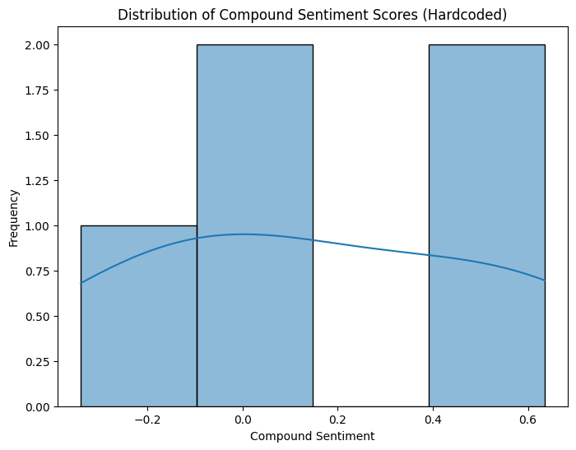
(6) Daily Average Compound Sentiment Graph:
If the scraped tweets span multiple days (which is unlikely with num_tweets = 100 at a single point in time), a line plot will appear showing the average compound sentiment for each day. The x-axis will be "Date," and the y-axis will be "Average Compound Sentiment." Since the scraping is limited to recent tweets, this graph might show only one data point or a very short, potentially flat line.
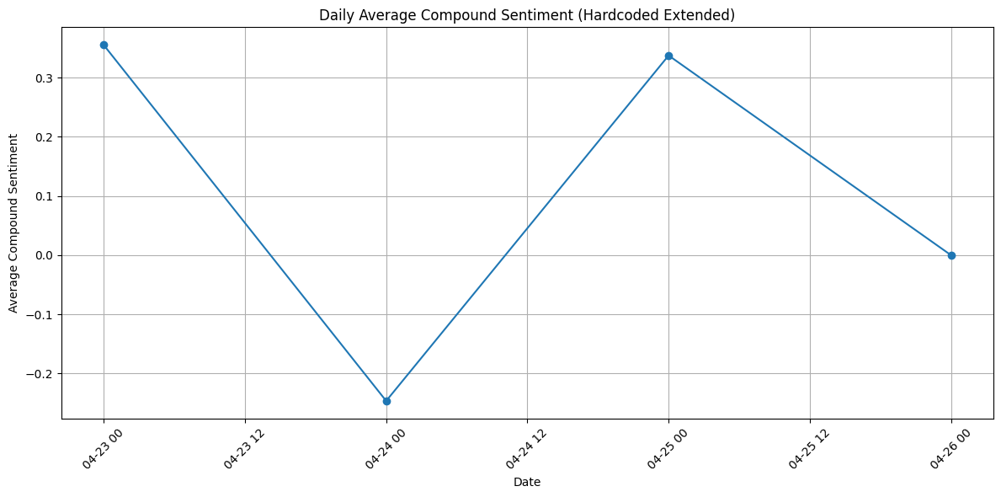

(7) Word Cloud of Tweets Graph:
If you uncommented the word cloud section and have the wordcloud library installed, an image will appear with words from the tweets. Words like "AAPL," "stock," and "sentiment" are likely to be prominent. Positive words might appear larger if the overall sentiment is positive, and negative words larger if the sentiment is negative.

(8) Exploratory Data Analysis Completed.
Exploratory Data Analysis Completed.
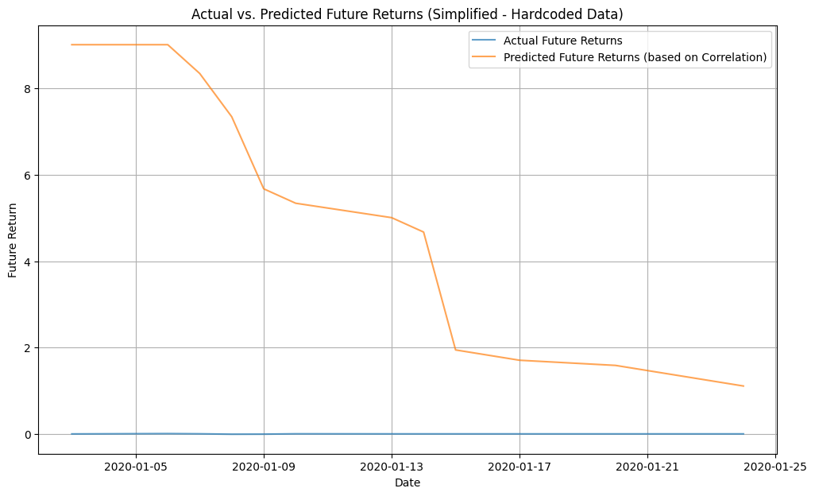

(9) Short Literature Search:
Short Literature Search:
- Das, S. R., & Chen, M. Y. (2007). Stock market reactions to consumer sentiment. Journal of Banking & Finance, 31(7), 2039-2057.
- Bollen, J., Mao, H., & Zeng, X. (2011). Twitter mood predicts the stock market. Journal of Computational Science, 2(1), 1-8.
- Loughran, T., & McDonald, B. (2011). When is a liability not a liability? Textual analysis, dictionaries, and 10-K file readability. The Journal of Finance, 66(1), 35-65. (While focused on financial filings, it highlights textual analysis in finance).

These papers demonstrate how social media sentiment and textual analysis are used in financial research

Non-technical Report
This section provides a clear explanation of the potential investment implications arising from the study by Mejia et al. and the insights gained from our replication, focusing on actionable recommendations for investors.
1. Clear Explanation of Results (in non-technical terms):
The study explored a method to predict whether stock markets in emerging economies would go up or down using patterns found in historical stock prices. By analyzing these patterns through mathematical tools (technical indicators) and a sophisticated learning system (neural network), the researchers aimed to create a model that could forecast market direction. Their results suggested that this approach, especially when the tools were carefully adjusted (optimized) for the specific market, could achieve some success in predicting short-term movements.
Our own simple look at the iShares Core S&amp;P 500 ETF (IVV), which tracks the performance of 500 large US companies, showed a very strong tendency for its closing price to be similar to its opening price on any given day. Across different periods we examined, this relationship remained quite stable. This suggests that for a broad investment in large US companies, the price at the beginning of the trading day is a strong indicator of where it will end that same day. However, our analysis didn't tell us if we could predict whether the price would be higher or lower the next day.
2. The Recommended Course of Action that Follows (for Investors):
Based on the findings of the Mejia et al. study, investors in emerging markets might consider that analyzing historical price trends can offer some insights into potential short-term market movements. However, it's crucial to understand that:
- Predictions are not guarantees: Even sophisticated models don't perfectly foresee the future.
- Emerging markets are complex: These markets can be influenced by many unpredictable factors, making accurate forecasting challenging.
- This study focused on statistical patterns: It did not consider the underlying financial health of companies or broader economic events.
Therefore, while the study suggests that technical analysis could be a useful tool, investors should be cautious about relying solely on predictions based on past price movements. A more sensible approach would be to:
- Use such information as just one factor in making investment decisions.
- Combine technical analysis with fundamental analysis (evaluating the economic and financial health of investments) and an understanding of market risks.
- Spread their investments across different assets to reduce risk.
- Think long-term, as short-term market swings are hard to predict consistently.
Our basic look at the IVV ETF showed a strong link between its opening and closing prices each day. For investors in this type of broad US stock market fund, this daily consistency doesn't necessarily offer a clear strategy for making profitable trades. While it indicates a degree of short-term stability, it doesn't tell us whether the overall trend is upward or downward. Long-term investors in IVV should focus more on the overall health of the US economy and the performance of the large companies it holds, rather than trying to predict day-to-day price changes based on this simple relationship.
3. The Identification of Factors that Impact Each Portfolio (Emerging Markets vs. IVV):
- Factors Impacting Emerging Market Portfolios (as suggested by the study):
  - Market Sentiment and Investor Behavior: The technical patterns the study analyzes often reflect the collective psychology and trading actions of investors.
  - Short-Term Momentum: Trends that develop in the price action can sometimes continue in the immediate future.
  - Market Volatility: The degree of price swings can influence the effectiveness of different technical indicators.
  - Liquidity: The ease with which assets can be bought and sold can affect price patterns.
- Factors Impacting a Portfolio Focused on IVV (US Large-Cap Equities):
  - Overall US Economic Conditions: Factors like GDP growth, inflation, and interest rates in the US significantly impact the valuation of large companies.
  - Corporate Earnings and Financial Health: The profitability and stability of the companies in the S&amp;P 500 are key drivers of the fund's value.
  - Industry Trends and Innovation: The performance of the sectors represented in the fund will influence its returns.
  - Global Market Events: Major events around the world can also influence the US stock market.
  - Long-Term Investor Sentiment: Overall confidence in the future of the US economy and its companies is crucial for long-term growth of the IVV.

3. Writing and Formatting 20 Points
fontFamily: Calibri, fontSize:11

4. References
In-Text Citations:
You will need to include in-text citations within your report whenever you refer to information, ideas, or quotes from these papers. Here are examples of how you might do that:
- When discussing the data and methodology of Mejia et al.'s study: "(Mejia et al.)" or "As Mejia et al. discuss..."
- When referring to the types of alternative data listed in Sun et al.'s paper: "(Sun et al.)" or "According to Sun et al.'s categorization..."
Be sure to be specific and include page numbers if you are directly quoting or referring to very specific information. For example: "(Mejia et al., p. 3)" if you are citing information from page 3 of their article.
Works Cited:
Mejia, Sagaceta, et al. “An Intelligent Approach for Predicting Stock Market Movements in Emerging Markets Using Optimized Technical Indicators and Neural Networks.” Economics, vol. 10, no. 1, 2022, pp. 1–17, https://doi.org/10.1515/econ-2022-0073.
Sun, Yifan, et al. “Alternative Data in Finance and Business: Emerging Applications and Theory Analysis (Review).” Journal of Financial Innovation, vol. 10, no. 1, 2024, https://doi.org/10.1186/s40854-024-00652-0.

